Computer Organisation 1 Week 10 Tutorial Questions

- ~(P v Q) ⇔ ~ Pˆ ~ Q Use de Morgan: Change operators: ~(P^Q)
Change sign of operands ~(~P^~Q)
Negate expression: ~P ^ ~Q
A+A’.B = A + B (Can use = instead of ⇔)
A + 1 = 1
A.1 = A
(a + b)(a + c) = a + bc ‘Multiply’ thru brackets: a.a + a.c + b.a + b.c
Gives a + a.c + b.a (both contained in a) + b.c. So, a + b.c

2. Show, by means of a truth table, that x.y’. (x + y + z) = x.y’

x y z (x + y + z) y’ x.y’ x.y’. (x+y+z)
0 0 0 0 1 0 0
0 0 1 1 1 0 0
0 1 0 1 0 0 0
1 0 0 1 1 1 1
0 1 1 1 0 0 0
1 0 1 1 1 1 1
1 1 0 1 0 0 0
1 1 1 1 0 0 0

3. Show by means of a truth table or otherwise that
P. (Q’ + R’) = ~(P + Q.R) Sorry! Error in this question: should be ~(P’ + Q.R) (Use de Morgan to prove)

(a + b) . (b’ + a) = a gives a.b’ + a.a + b.b’ + b.a
ie a.b’ + a + 0 + a.b
a contains a.b’ and a.b so result is a
4. Simplify the following logic expressions
A.B’ + A’.B’ Factor : B’(A + A’) gives B’
a.b + a’.b + a’.b’ Factor b to give: b.(a + a’) +a’.b’leads to b + a’.b’

(x + x’.y) + t.(t’+ w) x + x’.y + t.t’ + t.w gives x + x’.y + w

5. Design a logic network for each of the following so that the output is described by the Boolean expression

  - (a + b)(a’ + c)
  - a’b + bc + a
  - ac + a’ + bc’
  - abc + a’b’c’

6. Show how to represent OR using NAND logic gates
(Hint : Use De M’ to get NANDs : x+y = ~(x’y’) )

x + y leading to ~(x’ . y’) says it all: NAND is an inverter for one signal as well as NOT AND for two input signals…



7. Give a Boolean expression describing the output of each of these logic networks:

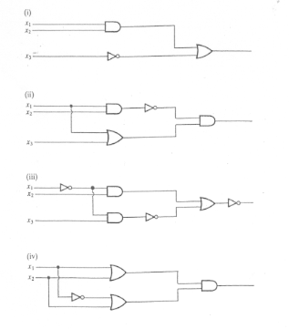
- (x1 . x2) + ~x3
- (x1 + x3). (x1.x2)’
- ~( (x1’ . x3)’ + x1’.x2) )
- (x1 + x2 ) . (x1’ + x2)

8. Find the NOR gate form for the Half-adder (Hint : Use De M’ on ab’ + a’b to get combinations of a+b, a’+b’ etc)

Apply de M’ separately to a.b’ to give ~(a’ + b), and to a’.b to give

This makes a.b’ + a’.b = ~(a’ + b) + ~ (a + b’)

A NOR gate to single input signal a yields a’….

